Third practical:

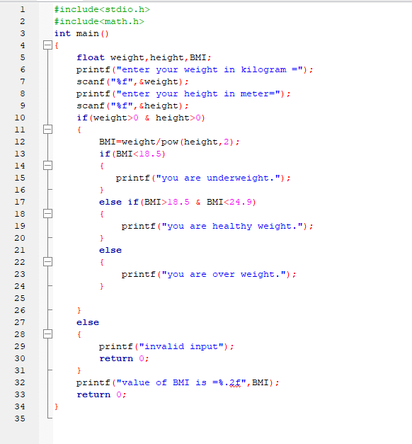

SS 1: input for BMI counting

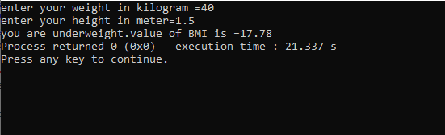

SS 2: output for BMI counting